MODULE 3

1) Select unique job from EMP table.

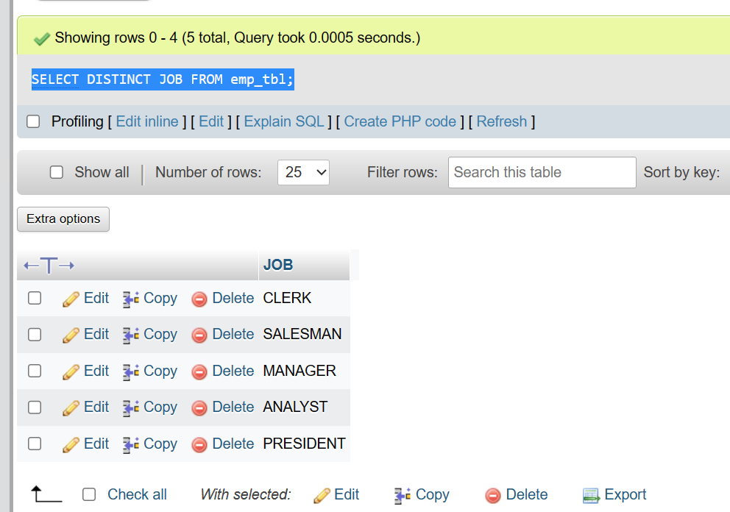

2) List the details of the emps in asc order of the Dptnos and desc of Jobs?

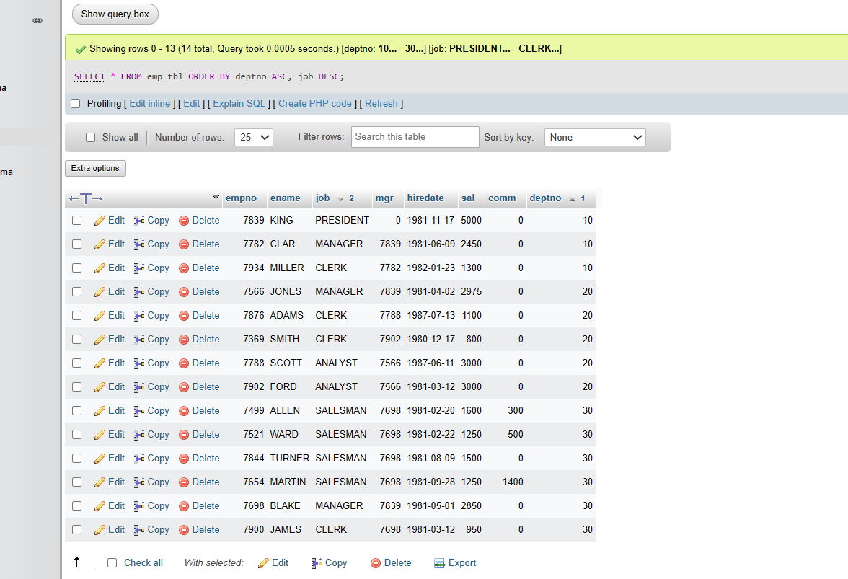

3) Display all the unique job groups in the descending order?

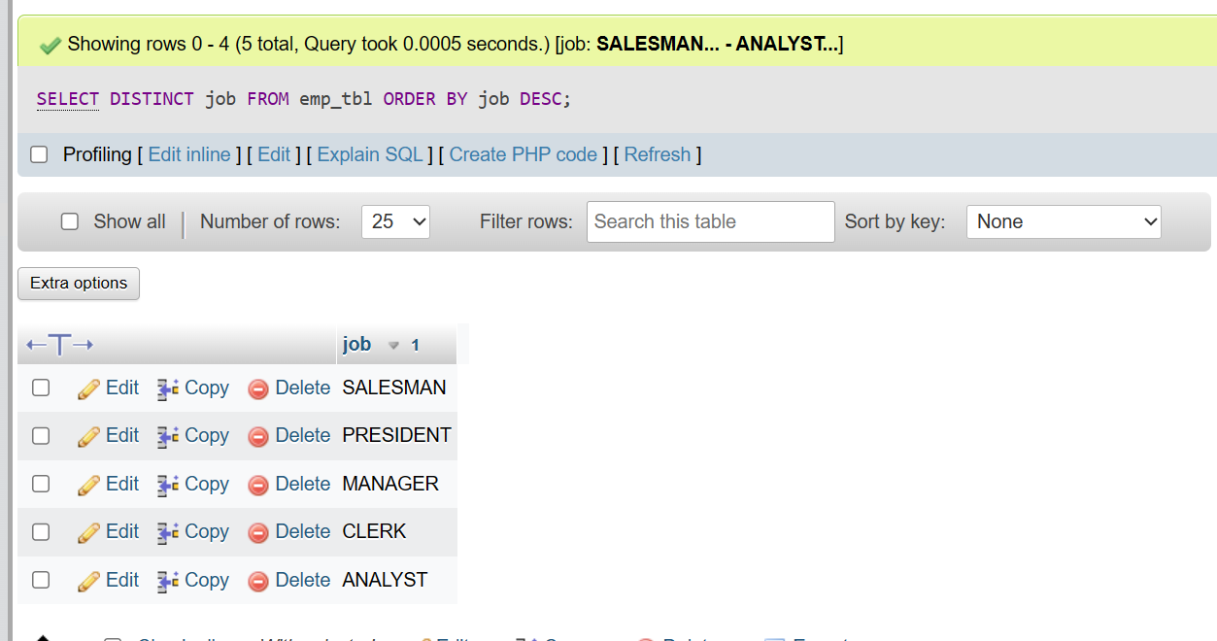

4) List the emps who joined before 1981.

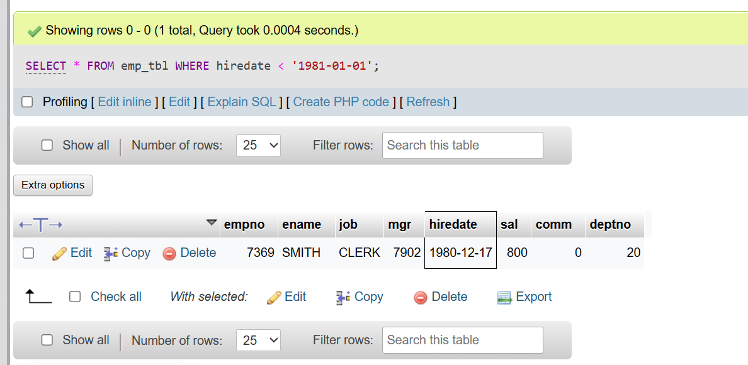

5) List the Empno, Ename, Sal, Daily sal of all emps in the asc order of Annsal.

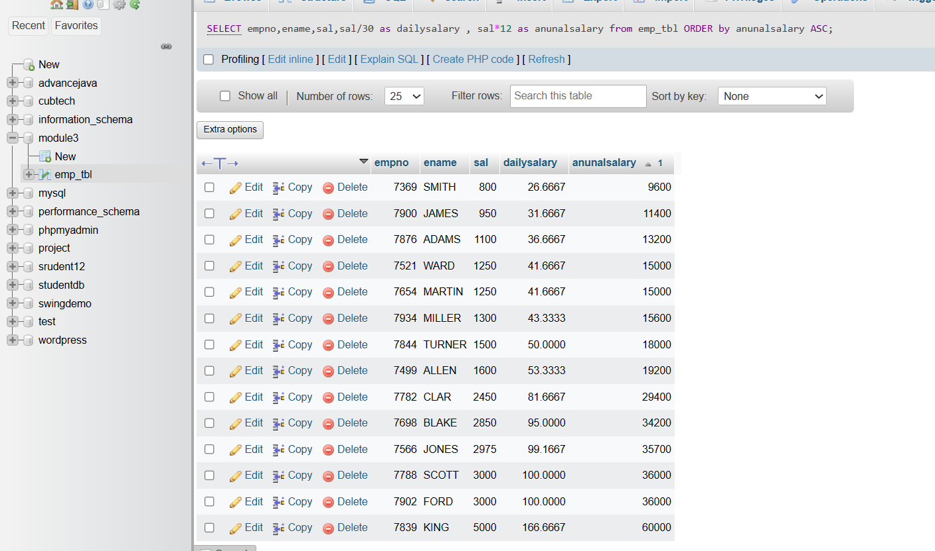

6) List the Empno, Ename, Sal, Exp of all emps working for Mgr 7369.

7) Display all the details of the emps who’s Comm. Is more than their Sal?

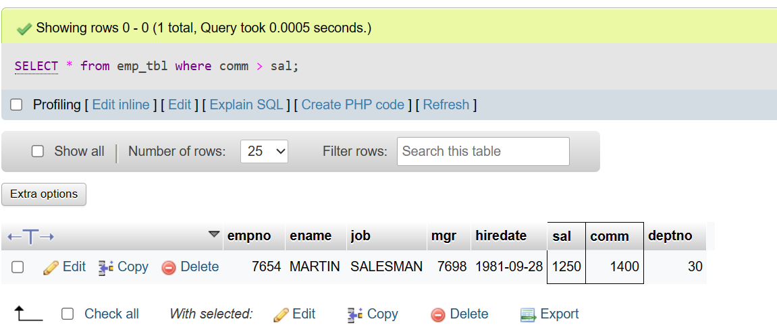

8) List the emps who are either ‘CLERK’ or ‘ANALYST’ in the Desc order.

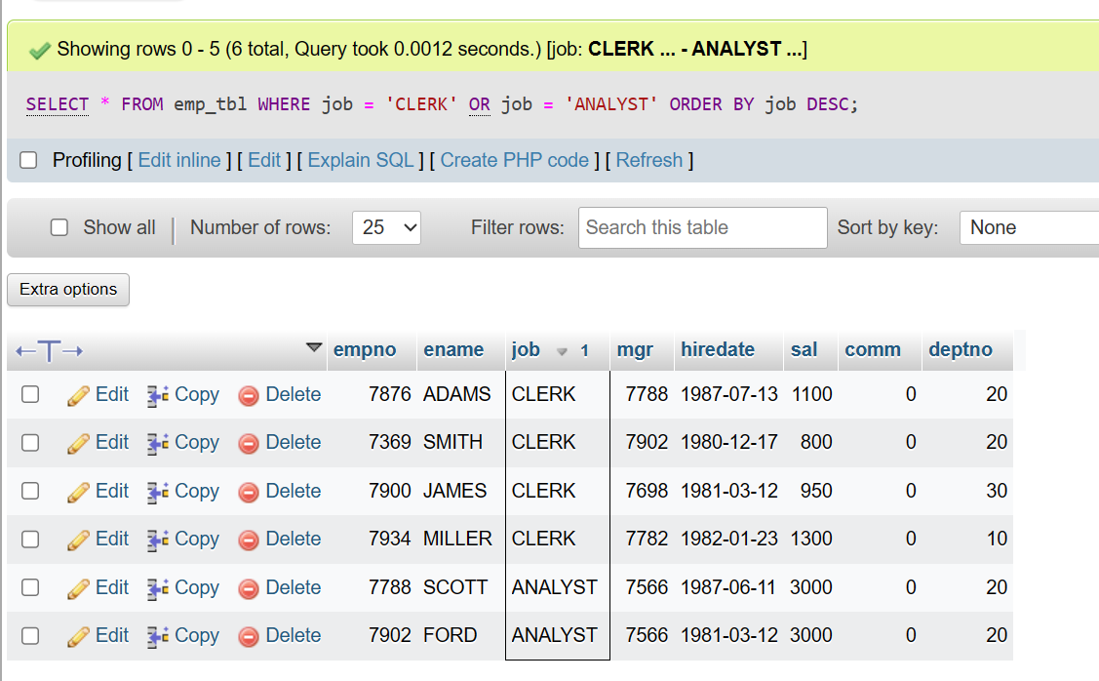

9) List the emps Who Annual sal ranging from 22000 and 45000.

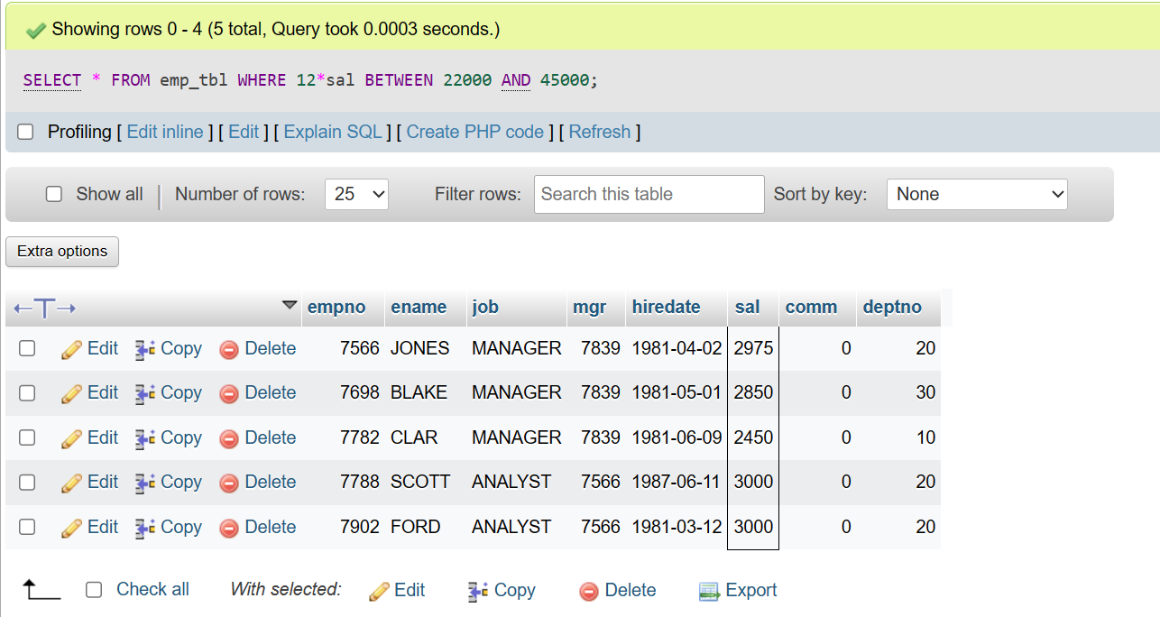

10) List the Enames those are starting with ‘S’ and with five characters.

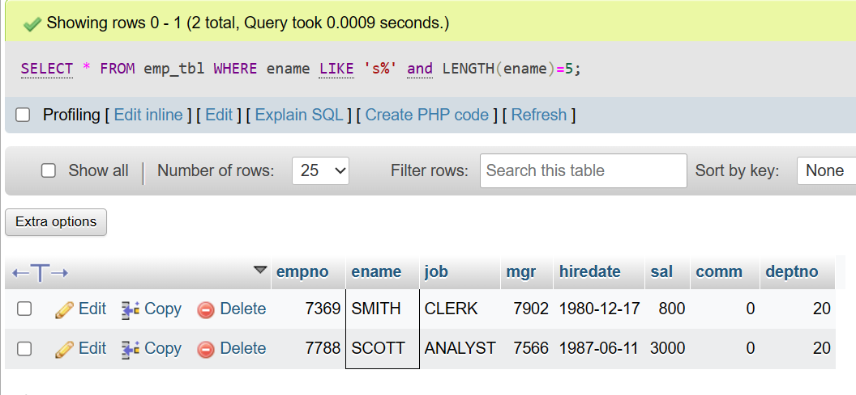

11) List the emps whose Empno not starting with digit 78.

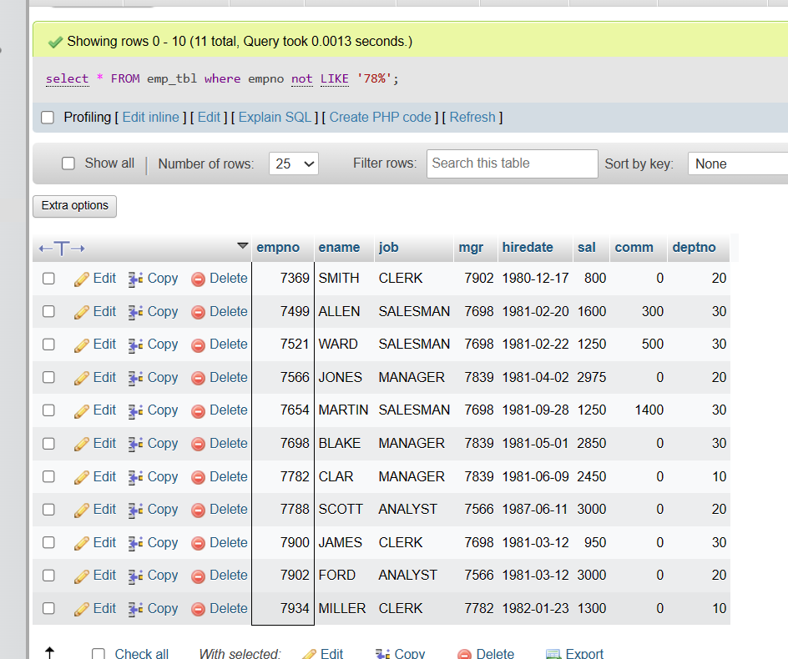

12) List all the Clerks of Deptno 20

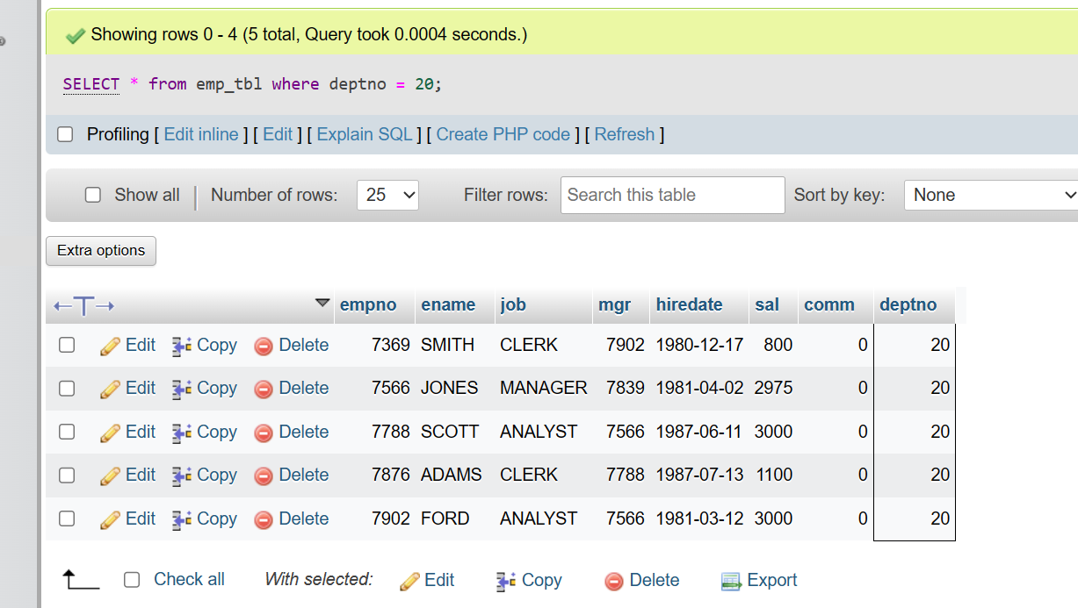

13) List the Emps who are senior to their own MGRS.

14) List the Emps of Deptno 20 who’s Jobs are same as Deptno10

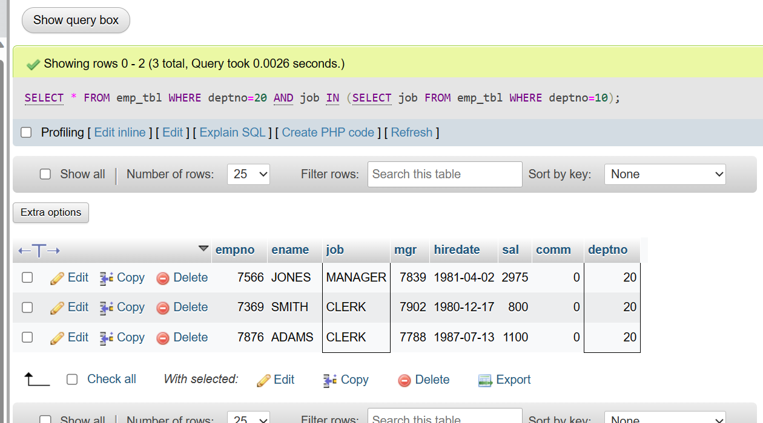

15) List the Emps who’s Sal is same as FORD or SMITH in desc order of Sal.

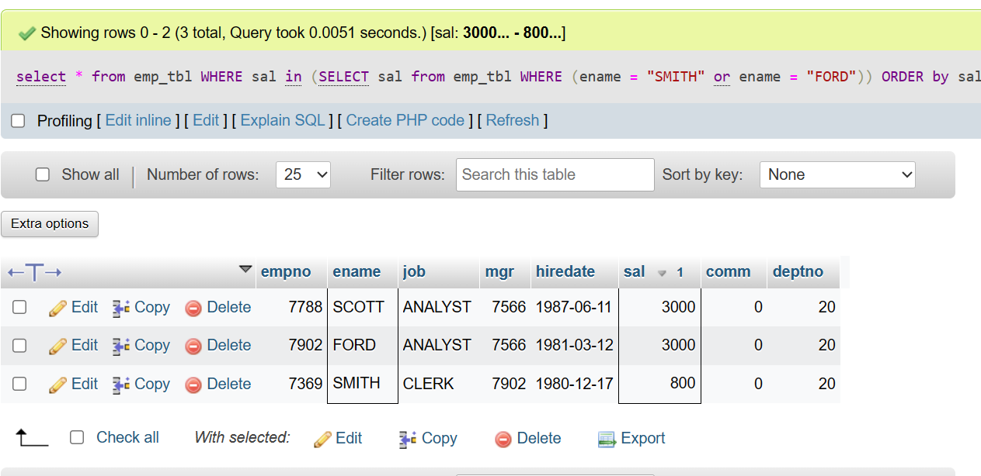

16) List the emps whose jobs same as SMITH or ALLEN.

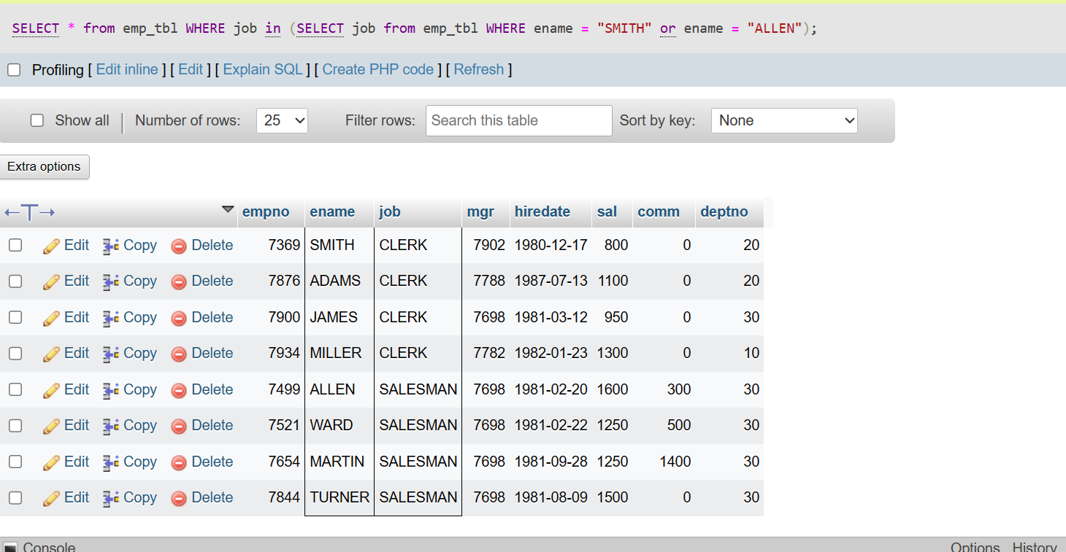

17) Any jobs of deptno 10 those that are not found in deptno 20.

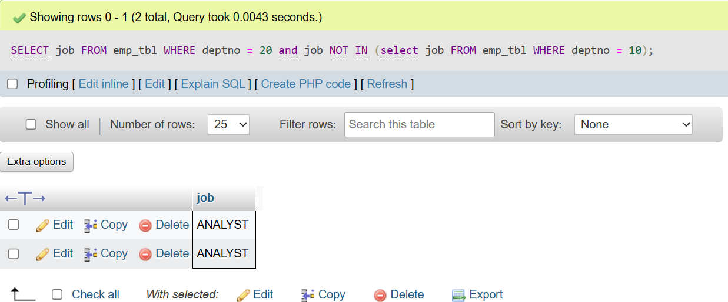

18) Find the highest sal of EMP table.

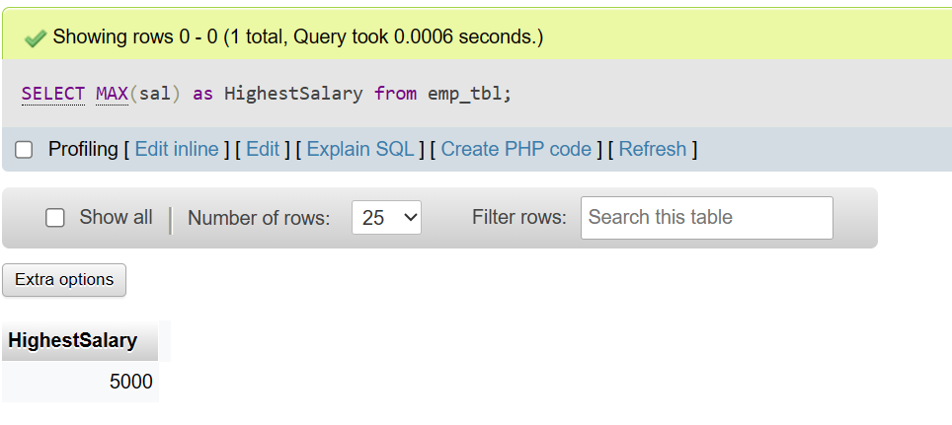

19) Find details of highest paid employee.

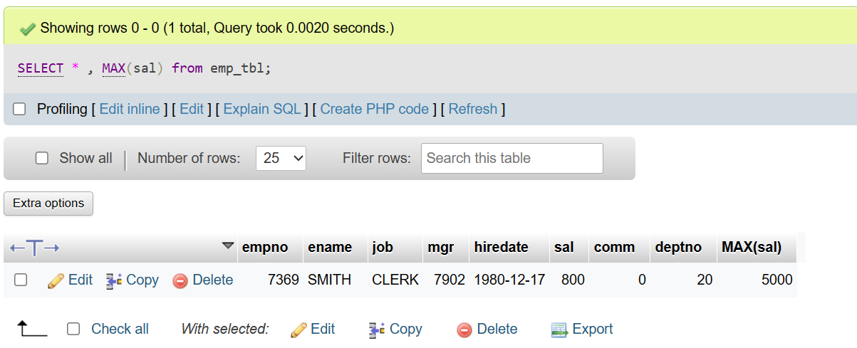

20) Find the total sal given to the MGR.

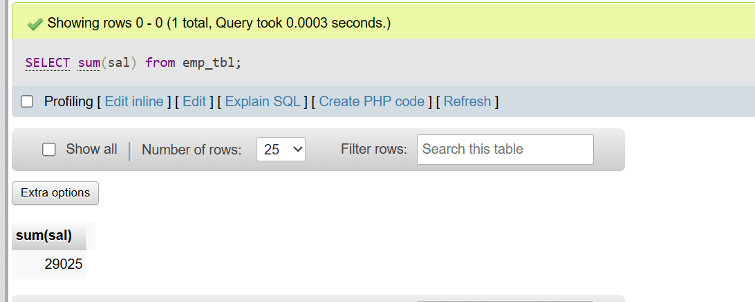

21) List the emps whose names contains ‘A’.

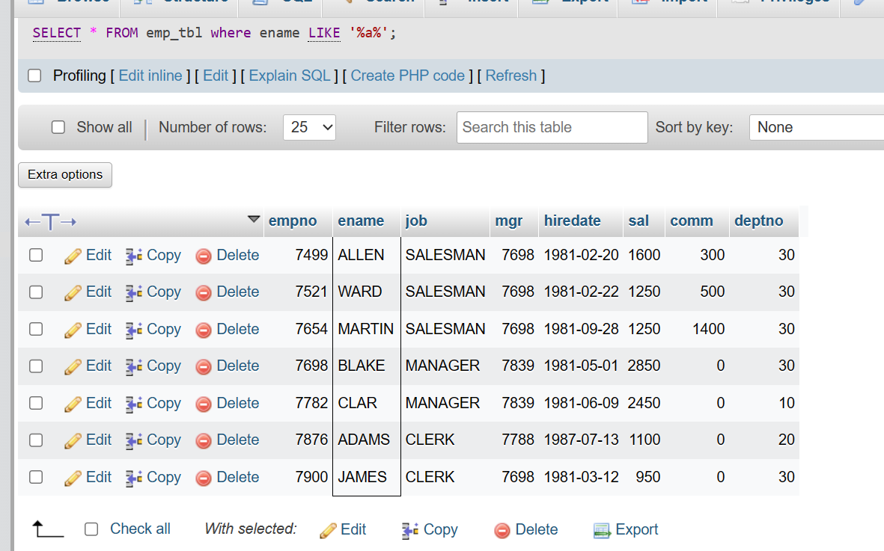

22) Find all the emps who earn the minimum Salary for each job wise in ascending order.

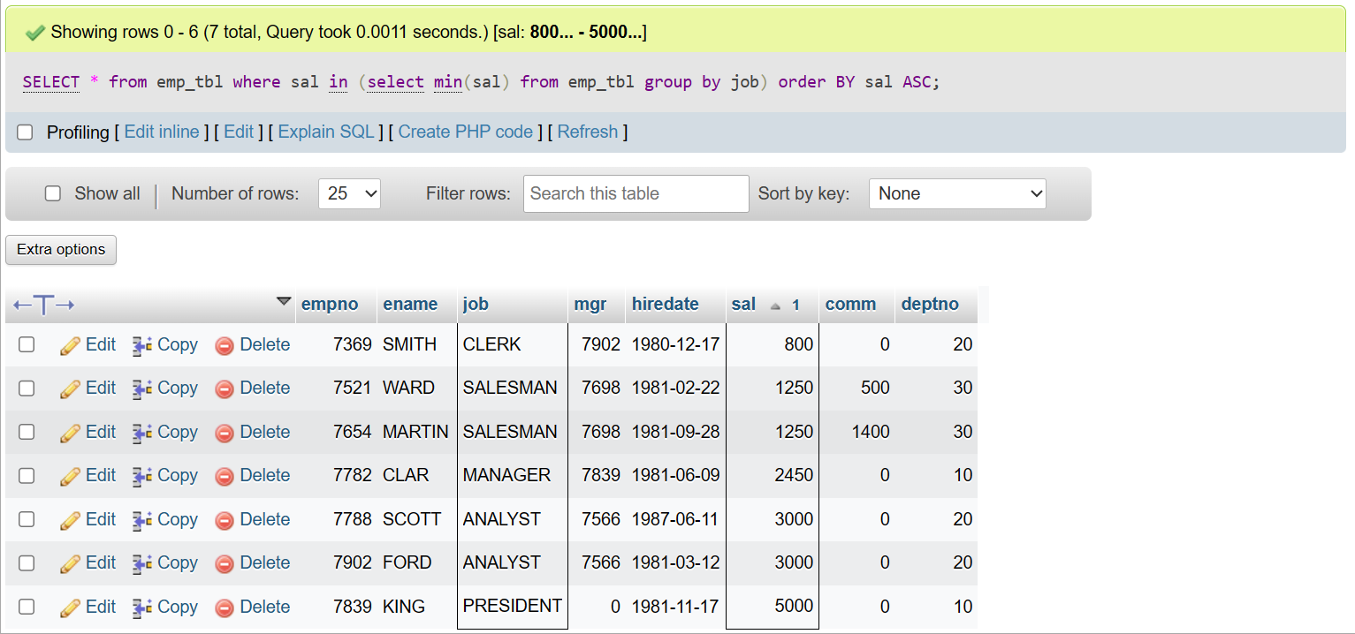

23) List the emps whose sal greater than Blake’s sal

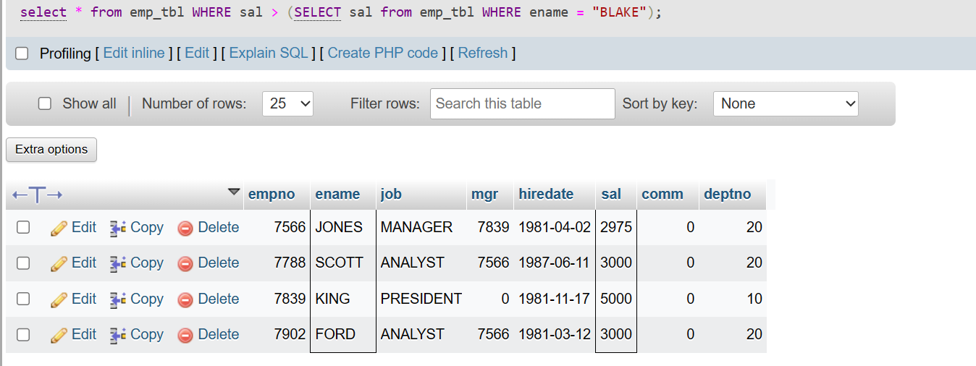

24) Add column Pin with bigint data type in table student.

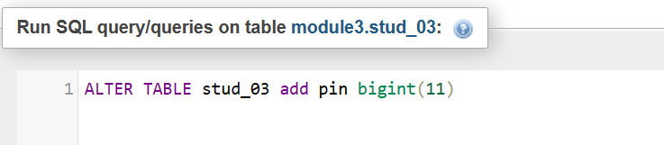

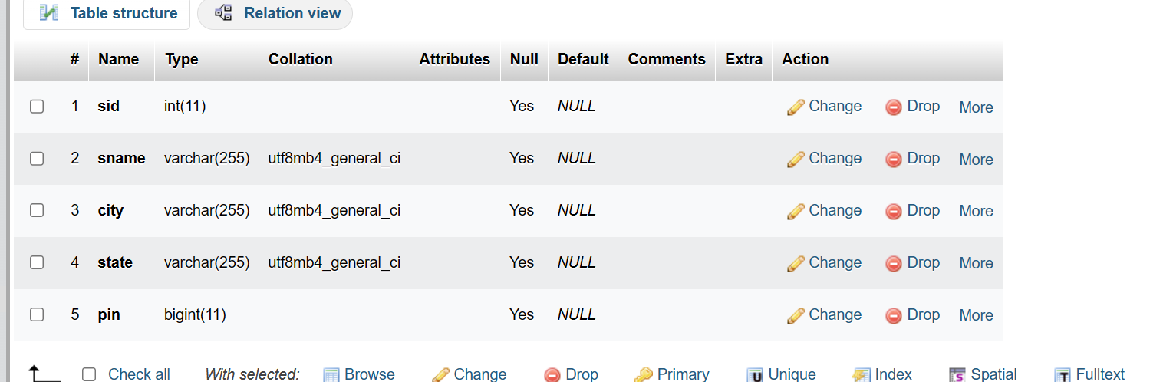

25) Modify the student table to change the sname length from 14 to 40.

